**LAB 10: USING CURL TOOL**

**Task 1:**

The general syntax for using curl is the following:

Curl [options] URL

This is a basic syntax that makes the tool quite simple to use. To get some more information on curl and how it is used, type curl –help to display the information screen.

Curl can be installed on Linux using the following command:

sudo apt-get install curl

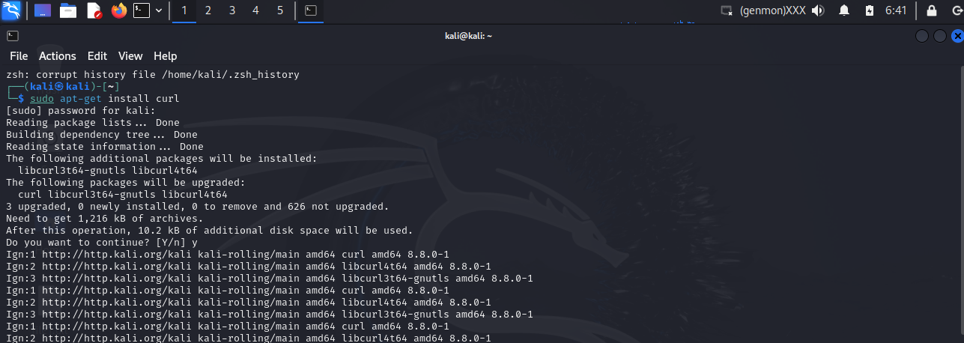

### Task 2:

The first task we will perform is getting the source code of a site. The first step is to boot your virtual machine and get Kali Linux up and running. Once this is complete, open a terminal and type the following:

curl [https://example.com](https://example.com/)

To save this output to a file, we will use either the “-o” or “-O” option. The lowercase option saves the file with a predefined filename, while the uppercase option saves the file with its original filename. Basically, the lowercase option allows us to specify a file name. This is a useful option if the webpage we are trying to inspect is preventing us from right clicking on the page to view the source code in the browser. Type the following to save your output:

curl -o output.txt [https://example.com](https://example.com/)

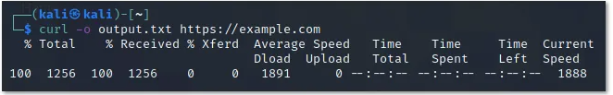

### Task 3:

Curl also provides you with the ability to download multiple files at once. To do this, use multiple -O options, followed by the URL of the file you want to download. For example:

curl -O https://arxiv.org/ftp/arxiv/papers/1610/1610.05971.pdf -O

https://arxiv.org/pdf/2103.08624.pdf

If your connection drops while downloading a file, you can resume the download with the “-C-“ option. This is an especially useful feature when downloading large sized files, ex DVD ISO files, or MP4 video files. This way, if your connection drops when downloading a file, you can resume the download instead of starting from scratch, using, for example:  
curl -C- -O https://arxiv.org/pdf/2103.08624.pdf